CHAPTER ONE
INTRODUCTION
1.1 Background of the Study
Attendance management is an essential administrative task in educational institutions, organizations, and workplaces. Traditional attendance systems such as manual signing, roll calling, and paper-based registers are time-consuming, error-prone, and susceptible to manipulation such as proxy attendance. With the rapid advancement of information and communication technology, there is a growing need for automated, accurate, and secure attendance systems.
Near Field Communication (NFC) is a short-range wireless communication technology that allows data exchange between devices over a distance of a few centimeters. NFC technology has gained widespread adoption in access control, mobile payments, identification systems, and smart cards. Its speed, ease of use, and enhanced security make it suitable for developing a smart attendance system.
The design and implementation of a smart attendance system using NFC aim to leverage this technology to automate attendance recording. In this system, each user is issued an NFC-enabled card or device that uniquely identifies them. Attendance is marked by tapping the NFC card on a reader, and the data is automatically stored in a centralized database for easy access and management.
1.2 Statement of the Problem
The existing time management methods in many institutions (such as schools, universities and organizations) are faced with several challenges. The major problems identified include:
- Time-consuming attendance process: Manual roll-calling consumes valuable lecture or meeting time, reducing productivity and effective use of time
- Accuracy in record keeping: Paper-based attendance records are prone to human errors such as incorrect marking, duplication, and omission of names.
- Impersonation: Students or employees may answer on behalf of absent colleagues, leading to unreliable attendance data.
- Difficulty in data retrieval: Searching for past attendance records in manual registers is stressful, slow, and inefficient.
- Risk of data loss or damage: Physical registers can be misplaced, damaged, or destroyed by fire, water, or wear and tear.
- Lack of real-time monitoring: Administrators cannot easily monitor attendance instantly or remotely using traditional systems.
- Poor report generation: Generating attendance summaries (daily, weekly, monthly) manually is tedious and prone to calculation errors.
These problems highlight the need for a smart attendance system using NFC (Near Field Communication) to automate, secure, and improve attendance management processes.
1.3 Aim and Objectives of the Study
Aim
The main aim of this study is to design and implement a smart attendance system using Near Field Communication (NFC) technology to improve the efficiency and accuracy of attendance management.
Objectives
The specific objectives of the study are to:
- Design a smart attendance system using NFC technology.
- Develop a system that uniquely identifies users through NFC cards or devices.
- Implement an automated attendance recording mechanism with minimal human intervention.
- Store attendance records securely in a database for easy retrieval and reporting.
- Reduce attendance fraud such as impersonation and proxy attendance.
- Evaluate the performance and reliability of the proposed system.
1.4 Significance of the Study
The significance of this study lies in its contribution to improving attendance management processes. The proposed system offers a faster and more reliable alternative to manual and conventional methods. Educational institutions and organizations can benefit from accurate attendance records, improved time management, and reduced administrative workload.
The system enhances security by ensuring that only authorized NFC cards can be used to mark attendance. It also provides real-time data storage and reporting, making it easier for administrators to monitor attendance trends and make informed decisions. Furthermore, the study contributes to the application of NFC technology in smart systems and digital transformation initiatives.
1.5 Scope and Limitations of the Study
Scope
This study focuses on the design and implementation of an NFC-based smart attendance system suitable for use in educational institutions or organizations. The system covers user registration, attendance marking using NFC cards, data storage, and basic attendance reporting. The implementation may involve hardware components such as NFC readers and software components such as a database and user interface.
Limitations
- The system requires NFC-enabled cards or devices, which may involve initial setup costs.
- Attendance marking depends on the physical presence of the NFC card; lost or damaged cards may affect usability.
- The system may have limited scalability depending on the hardware and database capacity used.
- Security threats such as card cloning, though minimal, may still exist if advanced encryption is not implemented.
1.6 Definition of Terms
- NFC (Near Field Communication): A short-range wireless communication technology that enables data exchange between devices within a few centimeters.
- Smart Attendance System: An automated system designed to record and manage attendance using digital technologies.
- NFC Card: A card embedded with an NFC chip that stores a unique identification number.
- NFC Reader: A device that reads data from NFC-enabled cards or devices.
- Database: An organized collection of data used to store attendance records electronically.
- Automation: The use of technology to perform tasks with minimal human intervention.
- Impersonation: The act of marking attendance on behalf of another person without authorization.

CHAPTER TWO
LITERATURE REVIEW
2.1 Review of Relevant Concepts (Conceptual Review)
2.1.1 Attendance Management Systems
An attendance management system is a structured approach used to record, track, and manage the presence or absence of individuals in an institution or organization. Traditional systems rely on manual processes such as roll calls and sign-in sheets, which are prone to errors, time delays, and manipulation. Modern attendance systems leverage digital technologies to automate record keeping, improve accuracy, and reduce administrative workload.
2.1.2 Smart Attendance Systems
Smart attendance systems utilize advanced technologies such as RFID, NFC, biometrics, QR codes, and mobile applications to automate attendance tracking. These systems minimize human intervention and provide real-time data storage and reporting. Smart attendance systems are widely adopted in educational institutions and corporate environments due to their efficiency, reliability, and ease of integration with other management systems.

2.1.3 Near Field Communication (NFC) Technology
Near Field Communication (NFC) is a short-range wireless communication technology that operates at a frequency of 13.56 MHz and allows data exchange over a distance of about 4–10 centimeters. NFC is derived from Radio Frequency Identification (RFID) technology and supports fast, contactless communication. NFC can operate in three modes: reader/writer mode, peer-to-peer mode, and card emulation mode. In attendance systems, NFC is commonly used in reader/writer mode, where an NFC reader scans a card or tag to retrieve a unique identifier.
2.1.4 NFC-Based Identification Systems
NFC-based identification systems assign a unique identity to each user through an NFC card or enabled device. When the card is tapped on a reader, the system verifies the identity and performs predefined actions such as granting access or recording attendance. These systems are valued for their speed, low power consumption, and improved security compared to manual identification methods.
2.1.5 Database Management Systems
A database management system (DBMS) is software used to store, organize, and retrieve large amounts of data efficiently. In smart attendance systems, the DBMS plays a critical role by storing user details, attendance logs, timestamps, and reports. Popular databases used for such systems include MySQL, PostgreSQL, and SQLite. Proper database design ensures data integrity, security, and scalability.
2.2 Standard Structure and Process of the System in View
The NFC-based smart attendance system follows a structured process that integrates hardware and software components to achieve automated attendance recording.
2.2.1 System Structure
The standard structure of the system consists of the following components:
- NFC Card/Tag: Issued to each registered user and contains a unique identification number.
- NFC Reader: Reads data from the NFC card when it is tapped.
- Processing Unit: Interprets the card data and communicates with the database.
- Database: Stores user information and attendance records.
- User Interface: Allows administrators to register users, view attendance, and generate reports.
2.2.2 System Process Flow
The system operates through the following steps:
- User registration is carried out, and a unique NFC card is assigned to each user.
- The user taps the NFC card on the reader at the point of attendance.
- The NFC reader captures the unique identifier from the card.
- The processing unit verifies the identifier against the database.
- If verification is successful, attendance is recorded with date and time.
- The attendance data is stored in the database and can be accessed for reporting.
This structured process ensures fast attendance marking, eliminates duplication, and improves data accuracy.
2.3 Review of Related Literature
Several researchers have investigated the application of automated technologies in attendance management systems with the aim of improving accuracy, efficiency, and security. Different approaches such as manual systems, RFID, biometrics, QR codes, and NFC-based systems have been proposed and evaluated in existing literature.
According to Adeyemo and Adebayo (2018), traditional manual attendance systems are inefficient and prone to errors, including falsification and loss of records. Their study highlighted the need for automated systems to reduce administrative workload and improve reliability in academic institutions.
Want et al. (2015) described Near Field Communication (NFC) as a subset of RFID technology that operates over very short distances, making it more secure for identification-based applications. Their research emphasized that NFC minimizes unauthorized access and accidental readings, which are common drawbacks in conventional RFID systems.
A study by Patel and Shah (2019) examined an RFID-based attendance system and concluded that while RFID improves speed and automation, its long-range capability may lead to proxy attendance. This limitation encouraged further research into short-range technologies such as NFC, which require intentional physical interaction.
Kaur and Singh (2020) developed an NFC-based smart attendance system for educational institutions and reported significant improvements in attendance accuracy and time efficiency. Their system demonstrated that NFC technology reduces impersonation and ensures that attendance is recorded only when the individual is physically present.
Research conducted by Alade, Ojo, and Balogun (2021) explored the integration of NFC attendance systems with database management systems. Their findings showed that centralized databases enhance data security, enable real-time attendance tracking, and simplify report generation for administrators.
Similarly, Zhang et al. (2022) proposed a mobile-based NFC attendance system integrated with cloud storage. The study concluded that NFC-based systems are cost-effective, user-friendly, and scalable, though challenges such as card loss and security encryption must be addressed.
Overall, existing literature supports the adoption of NFC technology for smart attendance systems due to its short-range communication, enhanced security, and ease of use. These studies provide a strong theoretical and practical foundation for the design and implementation of the proposed NFC-based smart attendance system in this research.

CHAPTER THREE
METHODOLOGY AND SYSTEM ANALYSIS
3.1 Methodology Adopted
The methodology adopted for this study is the System Development Life Cycle (SDLC) using the Waterfall model. The Waterfall model is suitable for this project because it follows a structured, sequential approach that allows proper planning, analysis, design, implementation, and testing of the system.
The stages involved in the methodology include:
- Requirement Analysis: Understanding the attendance challenges and defining system requirements.
- System Design: Designing the architecture, database, and operational flow of the NFC attendance system.
- Implementation: Developing the system using NFC technology and database integration.
- Testing: Ensuring the system functions correctly and records accurate attendance data.
- Evaluation: Assessing system performance and reliability.
This methodology ensures clarity, proper documentation, and systematic development of the proposed system.

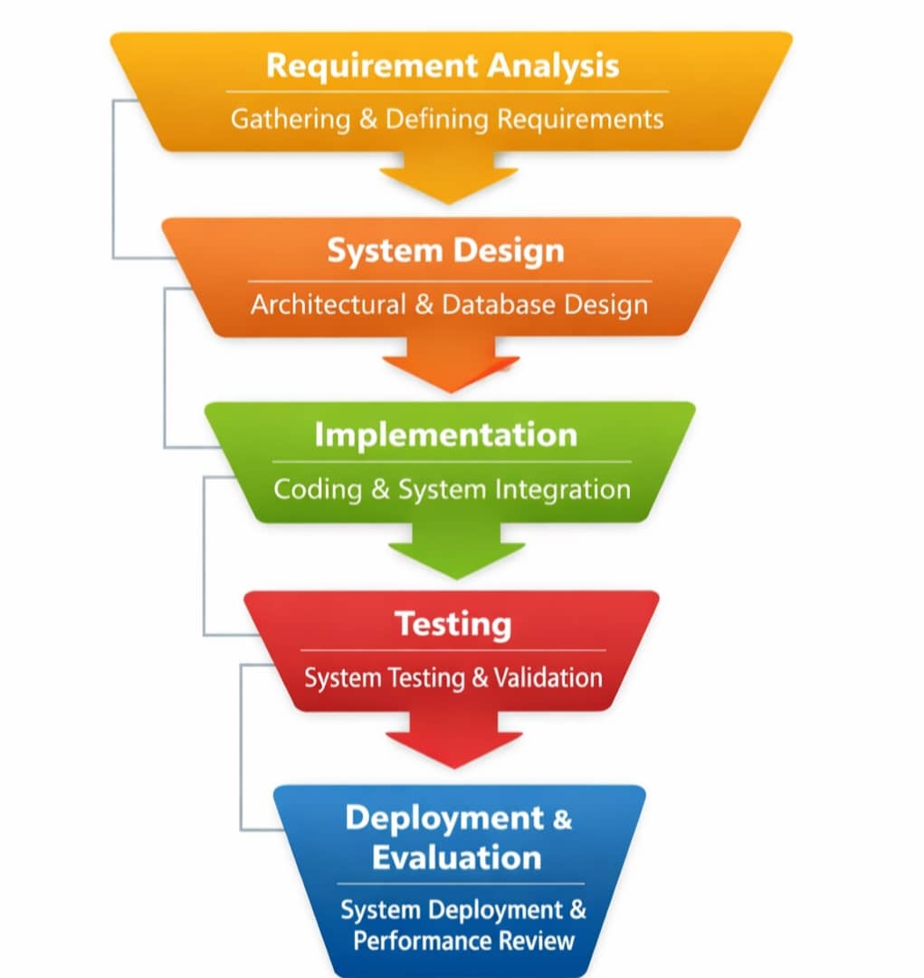

Fig 3.1: The waterfall Development Methodology
3.2 System Analysis
System analysis involves a detailed study of the existing attendance process in order to identify its shortcomings and determine the requirements for an improved system. The analysis focused on how attendance is taken, recorded, stored, and retrieved in institutions.
The analysis revealed that the current system relies largely on manual procedures, which are inefficient and vulnerable to errors and manipulation. These findings formed the basis for proposing an NFC-based smart attendance system that automates the entire process.
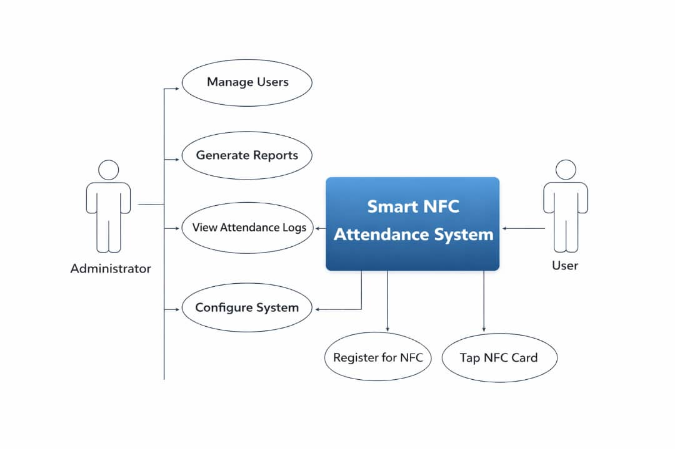
Fig. 3.2: Diagram of the Standard System

3.3 Analysis of the Existing System
The existing attendance system commonly used is the manual attendance system. In this system, attendance is taken by calling names or passing an attendance register for individuals to sign.
Procedure of the Existing System:
- Attendance registers are prepared manually.
- Names are called or registers are passed around.
- Individuals sign or respond to confirm presence.
- Attendance records are stored in physical files.
- Reports are generated manually when required.
- The system is heavily dependent on human effort and paper-based records.

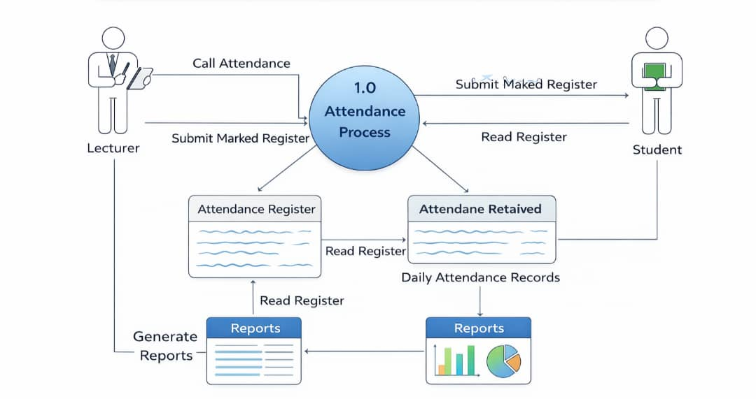
Fig 3.3: Dataflow Diagram of the Existing System
3.4 Weaknesses of the Existing System
The weaknesses of the existing attendance system include:
- Time Wastage: Attendance taking consumes a significant portion of time.
- Human Errors: Mistakes such as omission, duplication, and incorrect entries occur frequently.
- Impersonation: Proxy attendance is easy to carry out.
- Poor Data Storage: Physical records can be lost, damaged, or altered.
- Lack of Automation: Manual compilation of attendance is inefficient.
- Difficulty in Reporting: Generating attendance summaries is slow and stressful.
These weaknesses necessitate the development of an automated attendance system.
3.5 Analysis of the Proposed System
The proposed system is a Smart Attendance System using Near Field Communication (NFC). It is designed to automate attendance recording by using NFC-enabled cards or devices assigned to each user.
Operation of the Proposed System:
- Users are registered and assigned unique NFC cards.
- Attendance is marked by tapping the NFC card on an NFC reader.
- The system verifies the card identity from the database.
- Attendance is recorded automatically with date and time.
- Records are stored securely in a centralized database.
- Administrators can view and generate attendance reports easily.
The proposed system minimizes human involvement and ensures accurate record keeping.

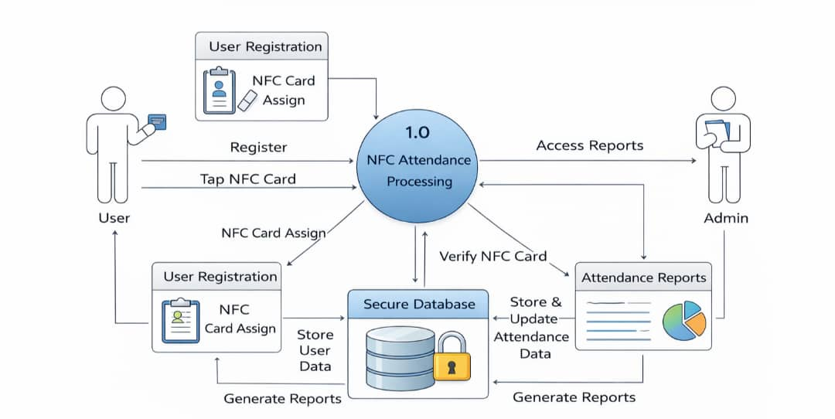

Fig 3.4 Data Flow diagram Of Proposed System
3.6 Advantages of the Proposed System (Compared to Existing System)
The proposed NFC-based attendance system offers the following advantages over the existing system:
- Faster Attendance Recording: Attendance is marked instantly.
- Improved Accuracy: Eliminates manual errors.
- Enhanced Security: Reduces impersonation and proxy attendance.
- Automated Data Storage: Attendance records are stored electronically.
- Easy Retrieval: Attendance data can be accessed anytime.
- Efficient Reporting: Reports can be generated automatically.
- Scalability: Suitable for both small and large institutions.
3.7 High-Level Model of the Proposed System
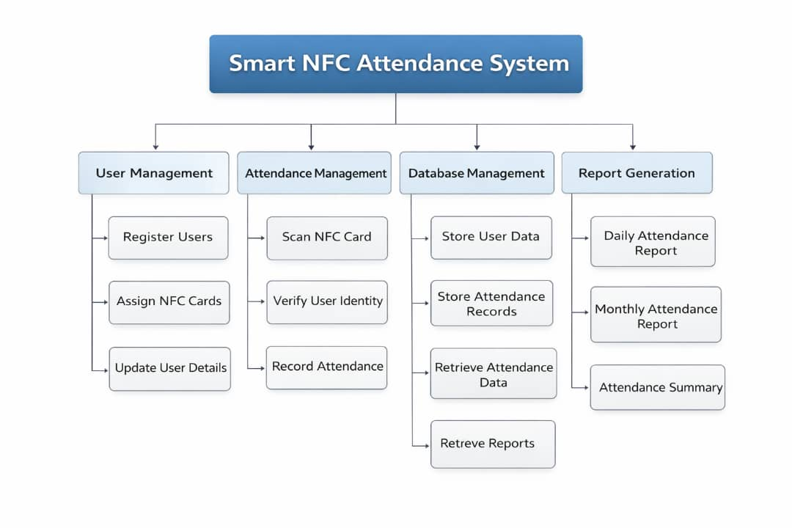
Fig 3.5: High Level Diagram Of the Proposed System
The high-level model of the proposed system shows the major components and their interactions within the NFC-based attendance system.
High-Level System Components:
- NFC Card/Tag: Used by users to mark attendance.
- NFC Reader: Reads the unique ID from the NFC card.
- Processing Unit: Verifies user identity and processes attendance data.
- Database: Stores user details and attendance records.
- Admin Interface: Allows monitoring, management, and report generation.
High-Level Operational Flow:
- User taps NFC card on the reader.
- Reader captures card ID and sends it to the system.
- System verifies card ID against the database.
- Attendance is recorded with date and time.
- Administrator accesses attendance data through the interface.
This high-level model provides an overview of how the proposed NFC-based attendance system functions as an integrated unit.

